G. A. Menon Academy (GAMA) Pages Training Calendar

Training Calendar - India & APAC
Sai Sree Jaganmay
i
Published yesterday • 14 min read
Follow


AI summary
The Monthly Learning Calendar highlights technical, behavioral, leadership, cloud certification, on-demand labs, and live courses across multiple formats (virtual, in-person, webinars) to support role-aligned growth.
Technical programs run Feb–Mar with 8-day structured courses (e.g., Python for Developers,
GCP, EDR/XDR, TOSCA, NodeJS, Agile & Scrum, Web Fundamentals, Azure, Design Thinking, DevOps with CI/CD, GraphQL, Kanban, UX, AWS, OWASP, Playwright, Power BI, etc.) and include clear time zones (IST, MYT, AEST, GMT) and weekly schedules (Mon/Thu or Tue/Fri).
Specialized certifications and programs include PRINCE2 webinar, and Talent Beacon cloud certification paths (AWS Cloud Practitioner, Google Cloud Digital Leader, Microsoft Azure Fundamentals) with distinct date ranges and time slots.
See more
This summary has been generated using AI

Monthly Learning Calendar
Stay updated with upcoming workshops, bootcamps, certification drives, and learning events every month. The calendar makes it easy to plan your learning in advance and participate in programs that align with your role and aspirations.
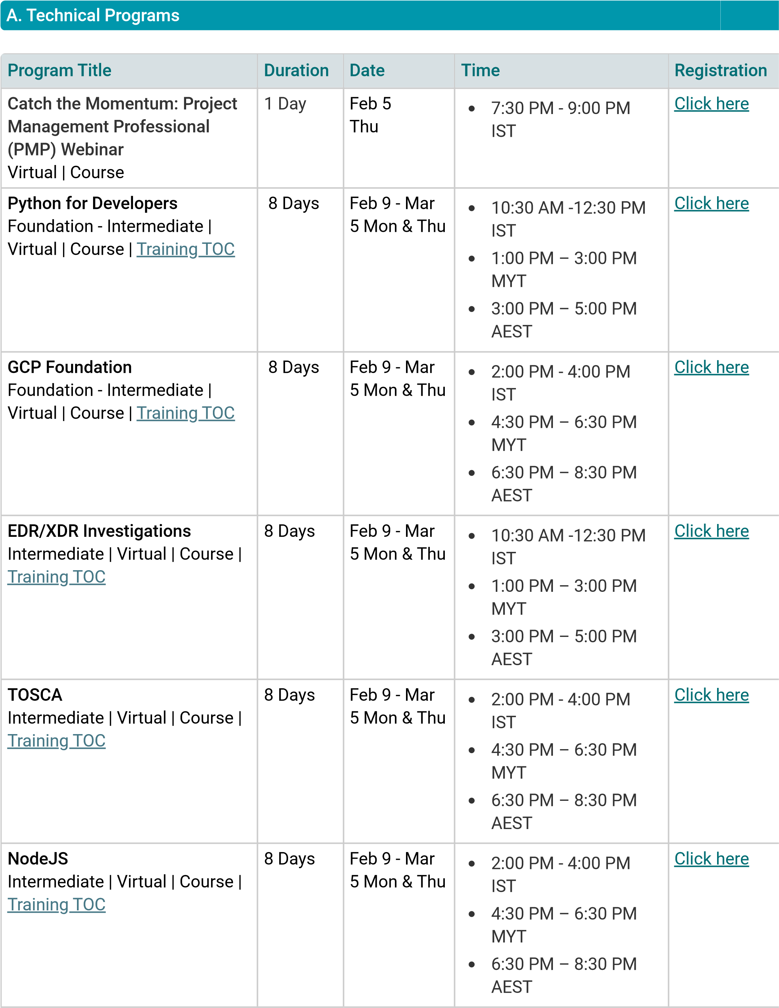

Agile & Scrum Fundamentals  Foundation | Virtual | Course |  Training TOC | 8 Days | Feb 9 - Mar  5 Mon & Thu | •  •  • | 10:30 AM -12:30 PM IST  1:00 PM – 3:00 PM MYT  3:00 PM – 5:00 PM  AEST | Click here
Coding Standards & Code  Review  Foundation | Virtual | Course |  Training TOC | 8 Days | Feb 9 - Mar  5 Mon & Thu | •  •  • | 2:00 PM - 4:00 PM IST  4:30 PM – 6:30 PM MYT  6:30 PM – 8:30 PM  AEST | Click here
Web Fundamentals  (HTML/CSS/JS)  Foundation - Intermediate |  Virtual | Course | Training TOC | 8 Days | Feb 10 -  Mar 6  Tue & Fri | •  •  • | 2:00 PM - 4:00 PM IST  4:30 PM – 6:30 PM MYT  6:30 PM – 8:30 PM  AEST | Click here
Azure Foundation  Foundation - Intermediate |  Virtual | Course | Training TOC | 8 Days | Feb 10 -  Mar 6  Tue & Fri | •  •  • | 10:30 AM -12:30 PM IST  1:00 PM – 3:00 PM MYT  3:00 PM – 5:00 PM  AEST | Click here
Design Thinking & Ideation  Intermediate | Virtual | Course |  Training TOC | 8 Days | Feb 10 -  Mar 6  Tue & Fri | •  •  • | 2:00 PM - 4:00 PM IST  4:30 PM – 6:30 PM MYT  6:30 PM – 8:30 PM  AEST | Click here
Azure DevOps with CI/CD  Foundation | Virtual | Course |  Training TOC | 8 Days | Feb 10 -  Mar 6  Tue & Fri | •  •  •  • | 3:00 PM - 5:00 PM IST  5:30 PM – 7:30 PM MYT  7:30 PM – 9:30 PM AEST  9:30 AM – 11:30 AM  GMT | Click here
GraphQL  Intermediate | Virtual | Course |  Training TOC | 8 Days | Feb 10 -  Mar 6  Tue & Fri | •  •  • | 10:30 AM -12:30 PM IST  1:00 PM – 3:00 PM MYT  3:00 PM – 5:00 PM  AEST | Click here

Kanban & Flow  Foundation | Virtual | Course |  Training TOC | 8 Days | Feb 10 -  Mar 6  Tue & Fri | •  •  • | 2:00 PM - 4:00 PM IST  4:30 PM – 6:30 PM MYT  6:30 PM – 8:30 PM  AEST | Click here
UX Principles & Design  Thinking  Foundation | Virtual | Course |  Training TOC | 8 Days | Feb 10 -  Mar 6  Tue & Fri | •  •  • | 10:30 AM -12:30 PM IST  1:00 PM – 3:00 PM MYT  3:00 PM – 5:00 PM  AEST | Click here
AWS Foundation  Foundation - Intermediate |  Virtual | Course | Training TOC | 8 Days | Feb 11 -  Mar 6  Wed & Fri | •  •  • | 10:30 AM -12:30 PM IST  1:00 PM – 3:00 PM MYT  3:00 PM – 5:00 PM  AEST | Click here
OWASP Top 10 & Secure  Coding  Intermediate | Virtual | Course |  Training TOC | 8 Days | Feb 11 -  Mar 6  Wed & Fri | •  •  • | 2:00 PM - 4:00 PM IST  4:30 PM – 6:30 PM MYT  6:30 PM – 8:30 PM  AEST | Click here
Playwright Automation  Intermediate | Virtual | Course |  Training TOC | 8 Days | Feb 11 -  Mar 6  Wed & Fri | •  •  • | 10:30 AM -12:30 PM IST  1:00 PM – 3:00 PM MYT  3:00 PM – 5:00 PM  AEST | Click here
Stakeholder & Change  Management  Foundation | Virtual | Course |  Training TOC | 8 Days | Feb 11 -  Mar 6  Wed & Fri | •  •  • | 10:30 AM -12:30 PM IST  1:00 PM – 3:00 PM MYT  3:00 PM – 5:00 PM  AEST | Click here
Power BI  Intermediate | Virtual | Course |  Training TOC | 8 Days | Feb 11 -  Mar 6  Wed & Fri | •  •  • | 2:00 PM - 4:00 PM IST  4:30 PM – 6:30 PM MYT  6:30 PM – 8:30 PM  AEST | Click here
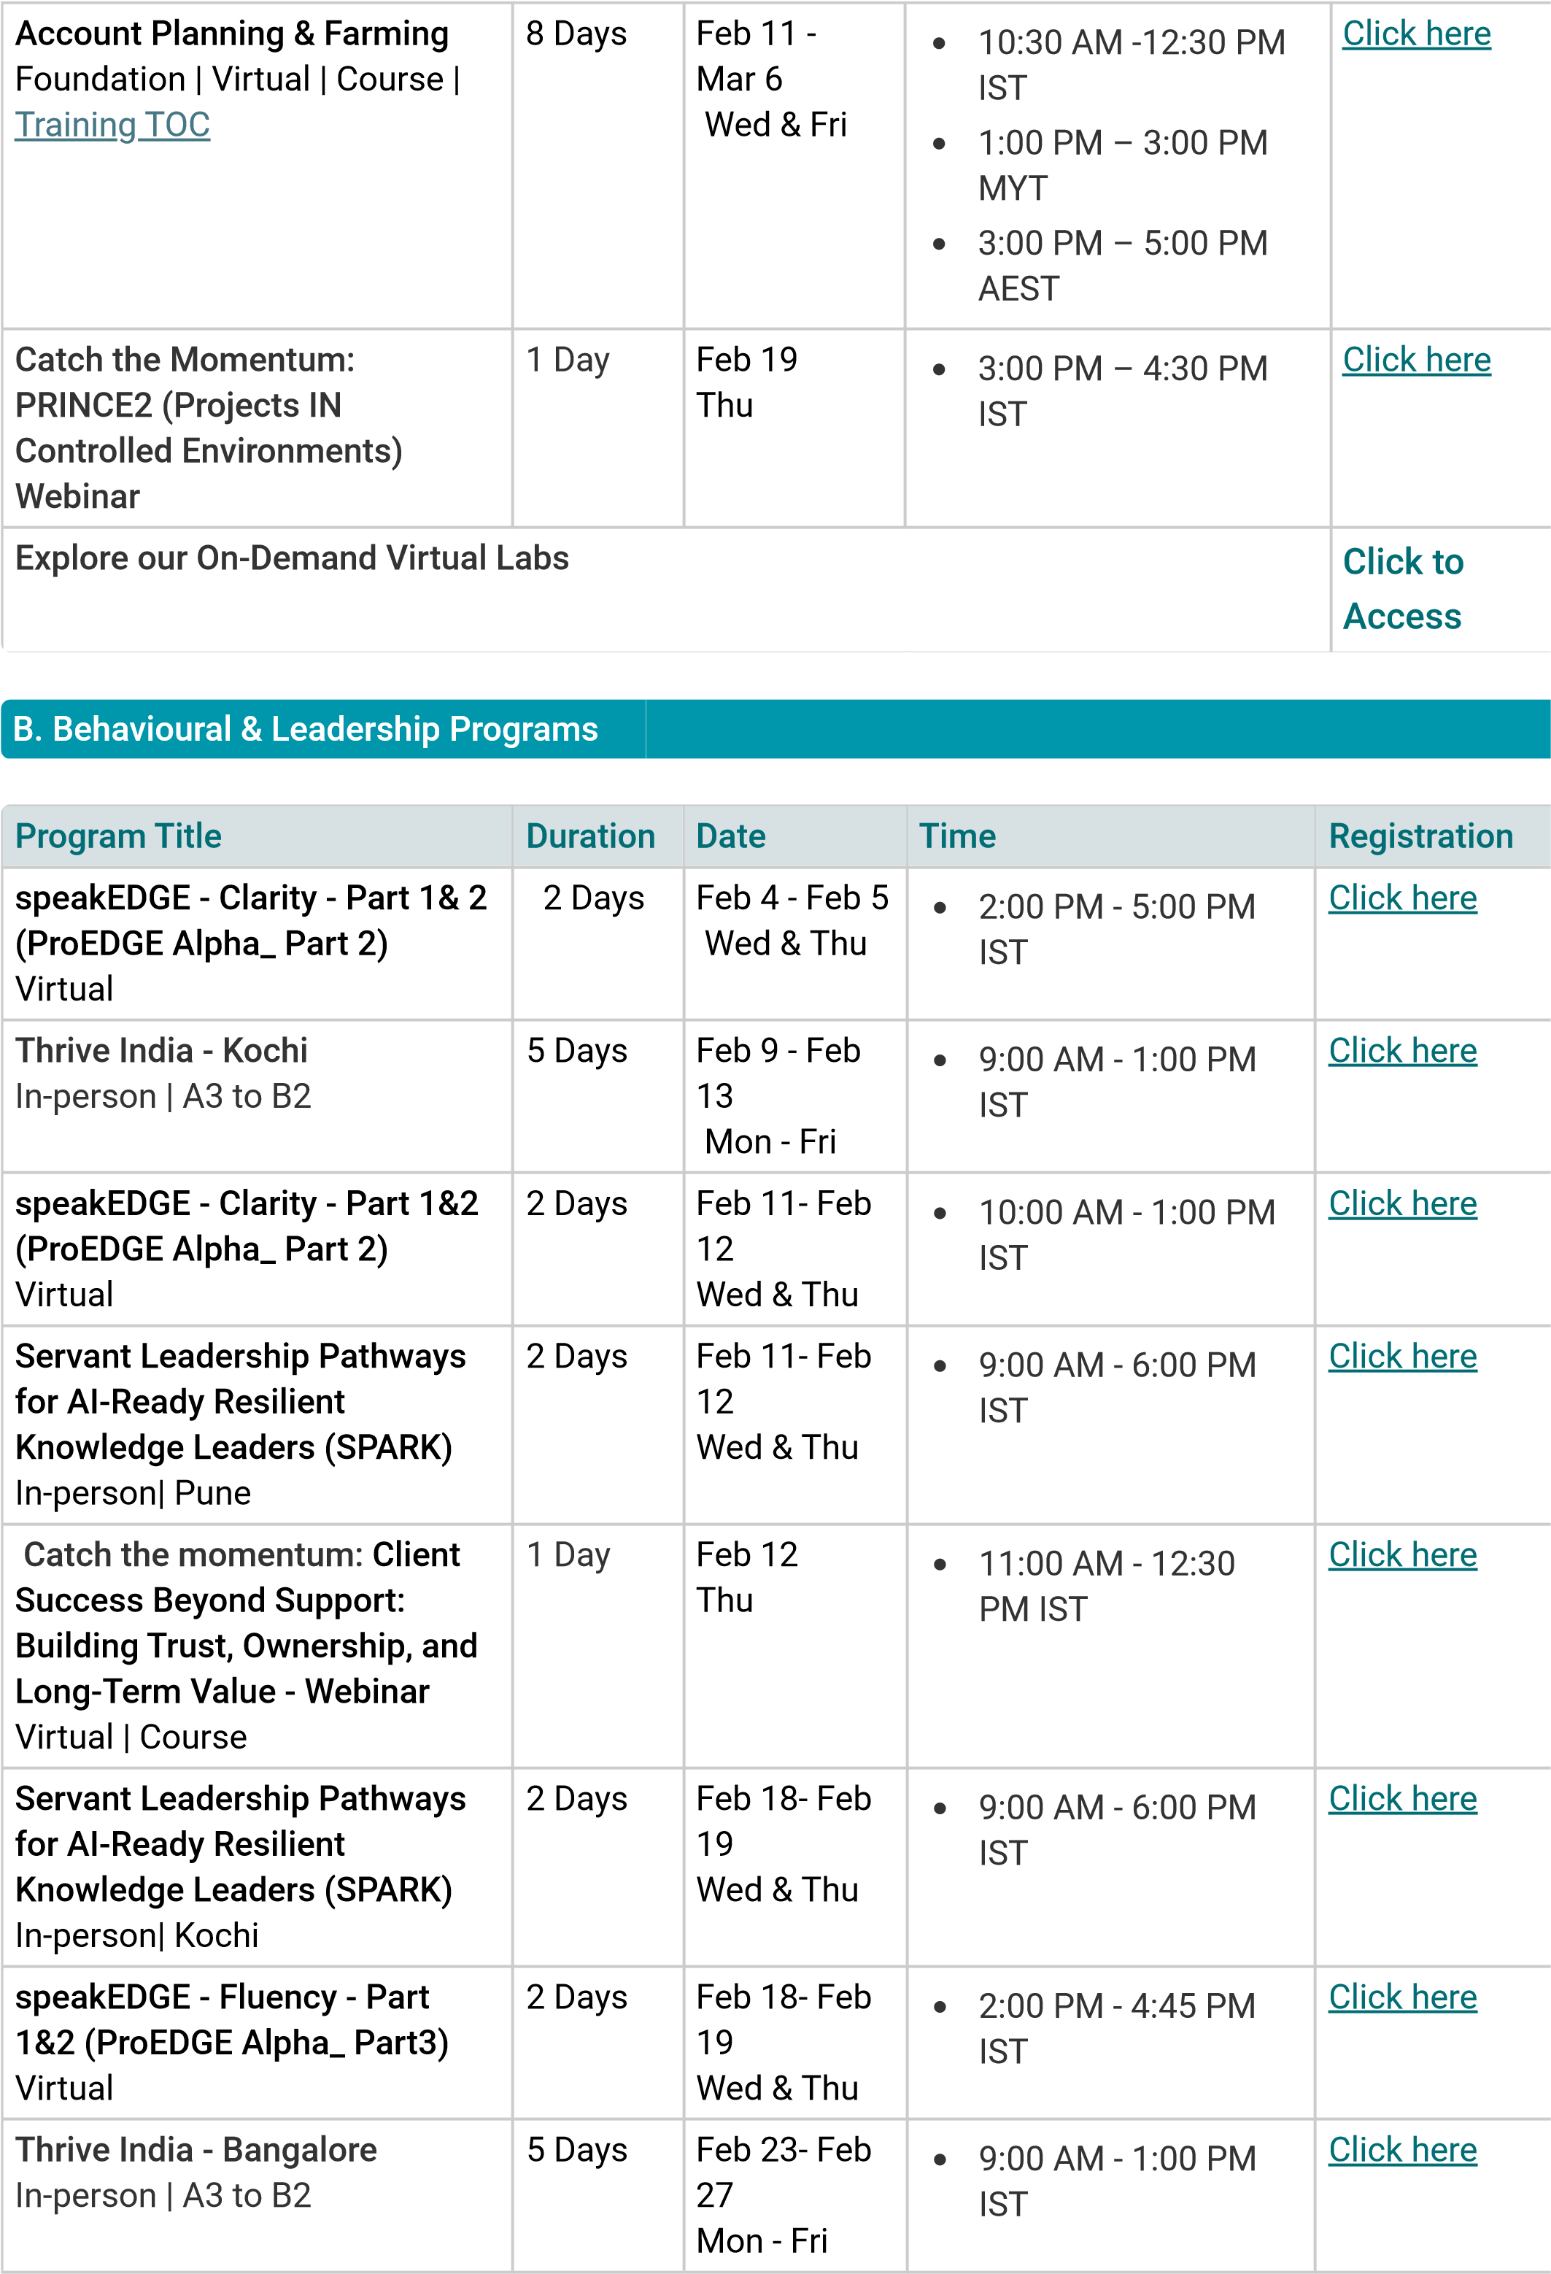
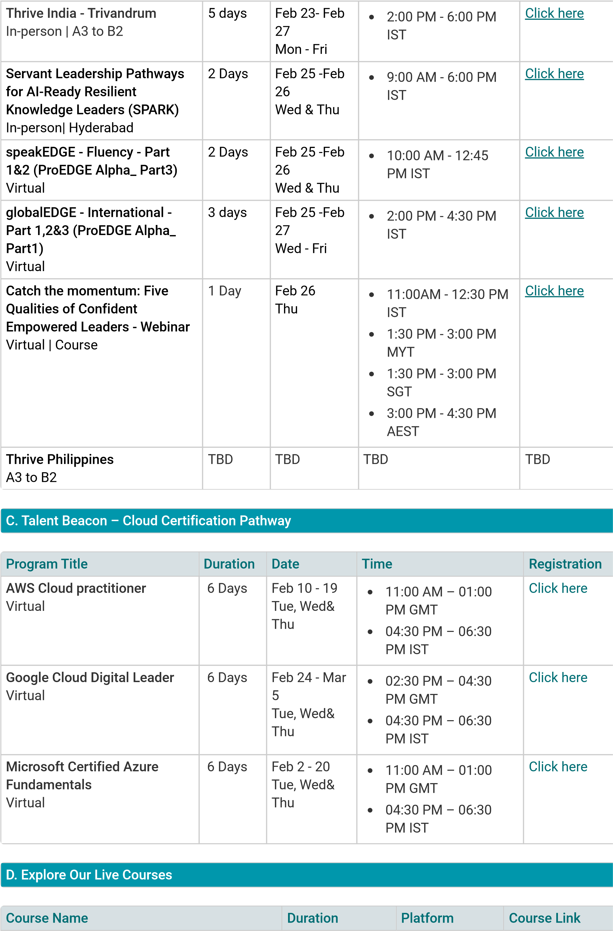
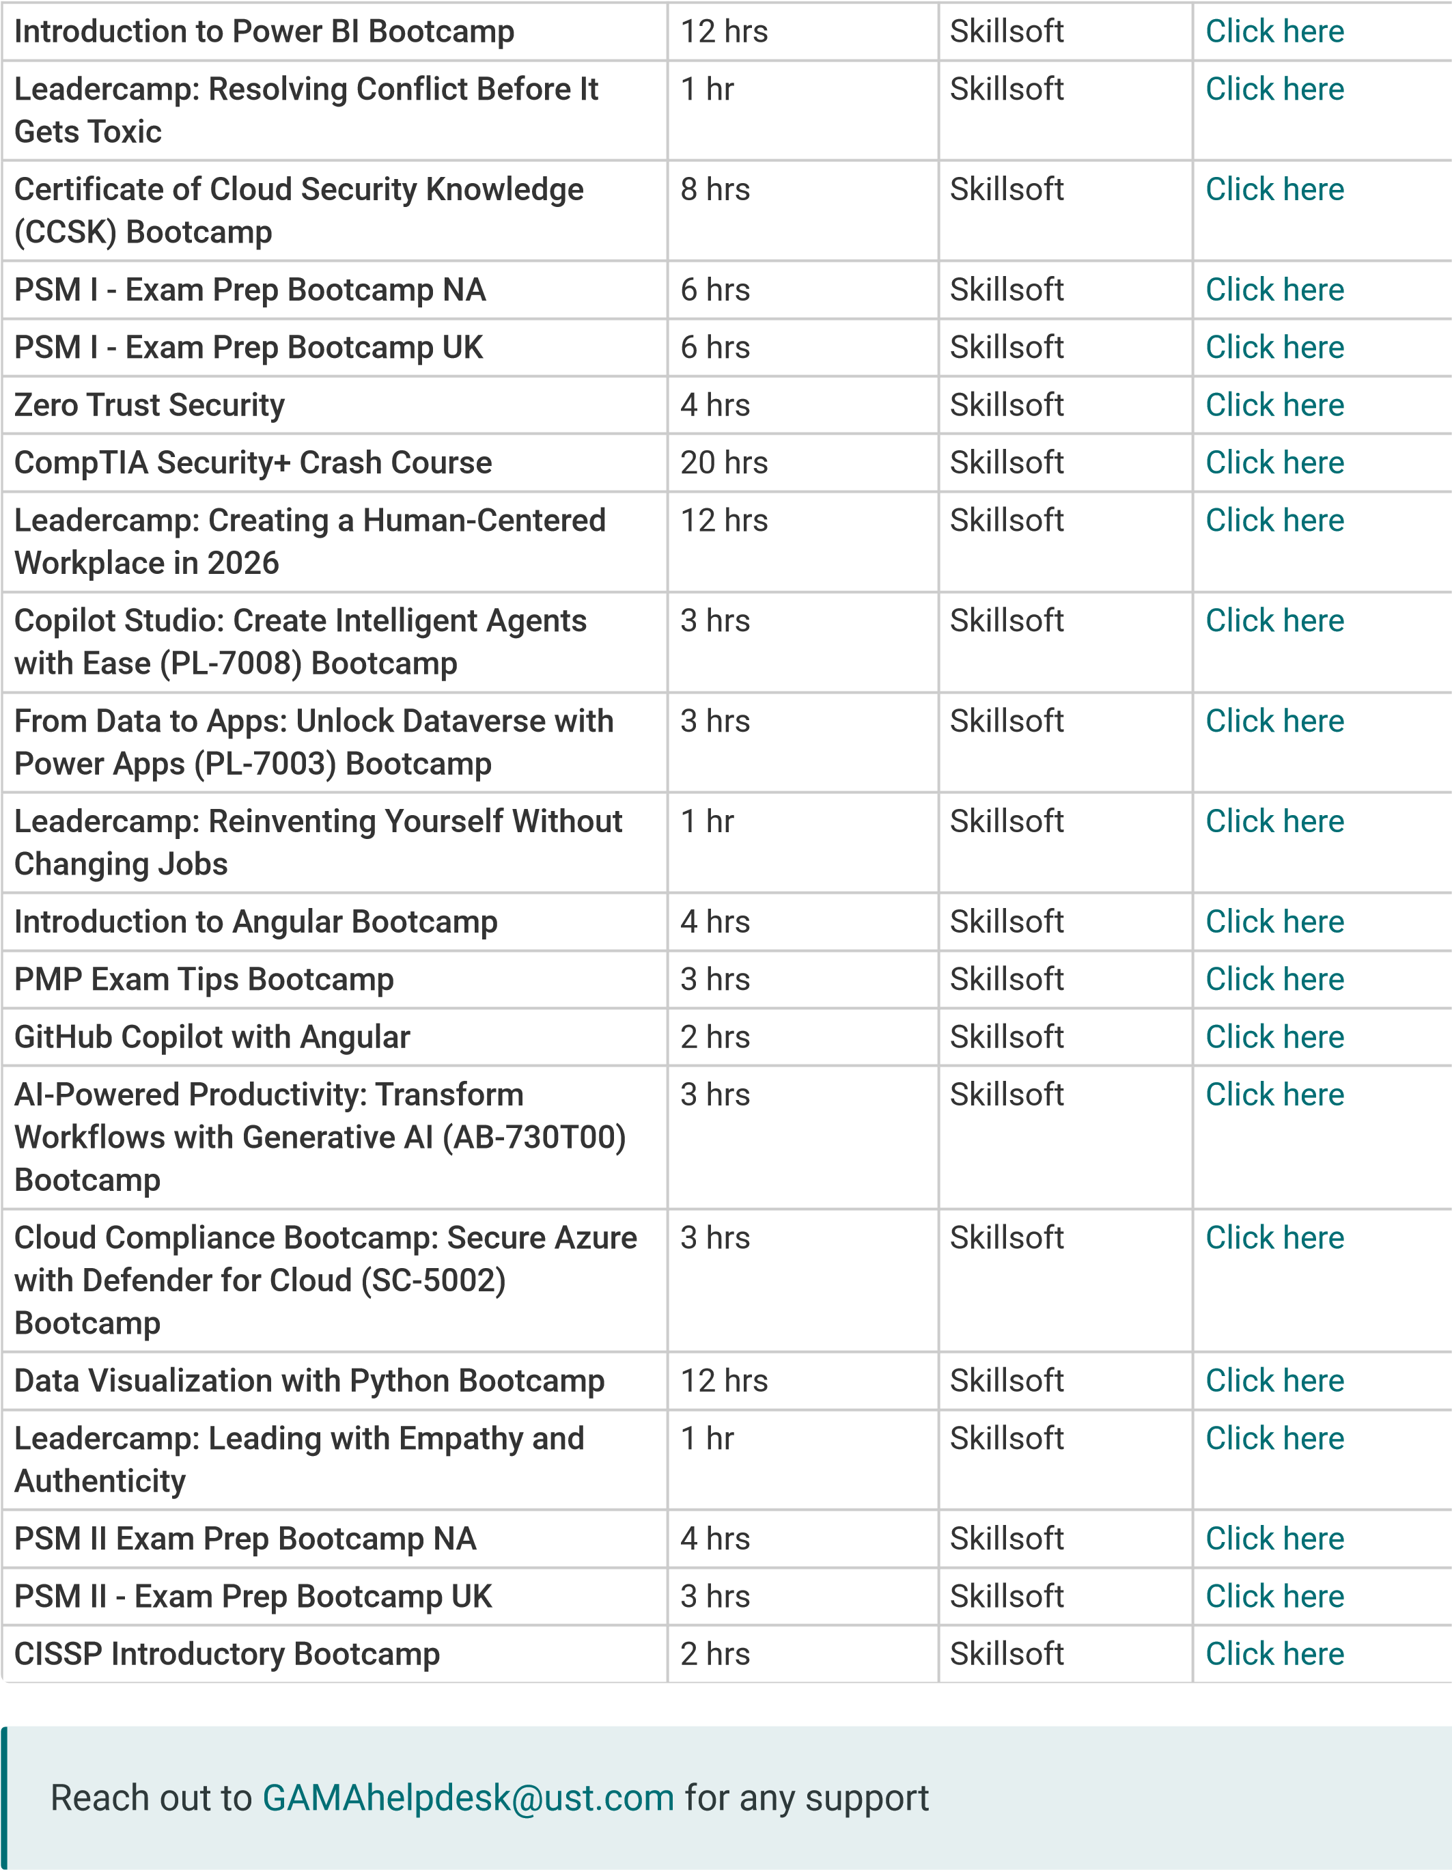
Topics
Training Calenda
r
Technical Program
s
Process Management Program
s
Behavioural & Leadership Program
s
Send feedback

Related content

Holiday calendar 2026_Chil
e
In Global Benefits & Total Rewards on Dec 30, 2025

Holiday calendar 2026_South Afric
a
In Global Benefits & Total Rewards on Dec 17, 2025

Training Calendar - Europe, UK, and Americ
a
In G. A. Menon Academy (GAMA) yesterday

